Name: Janani.K
Reg No: 192511243

EXP NO 3:
DATE: 04/08/2026
CREATE A SIMPLE CLOUD SOFTWARE APPLICATION FOR PROPERTY BUYING & RENTAL PROCESS (IN CHENNAI CITY) USING ANY CLOUD SERVICE PROVIDER TO DEMONSTRATE SAAS.
AIM:
To Create a simple cloud software application for Property Buying & Rental process (In Chennai city) using any Cloud Service Provider to demonstrate SaaS.
PROCEDURE:
step1: Go to zoho.com.
step 2: Log into the zoho.com.
step 3: Select one application step.
step4: Enter application name as property buying & rental.
step 5: Created new application as property buying & rental.
step 6: Select one form
step 7: The software has been created.

IMPLEMENTATION:
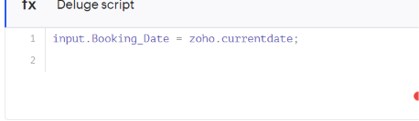
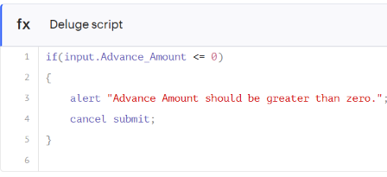
Output
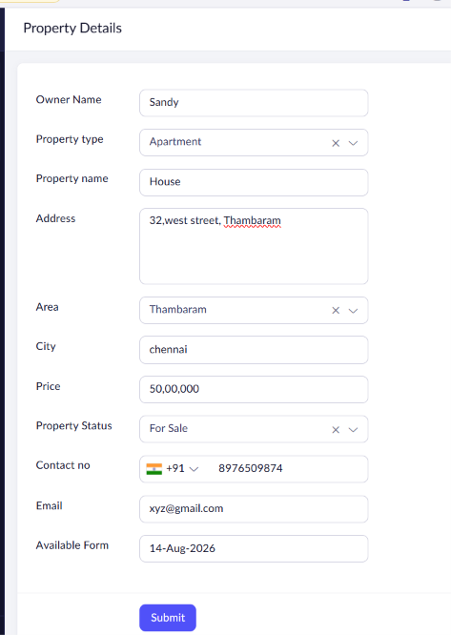
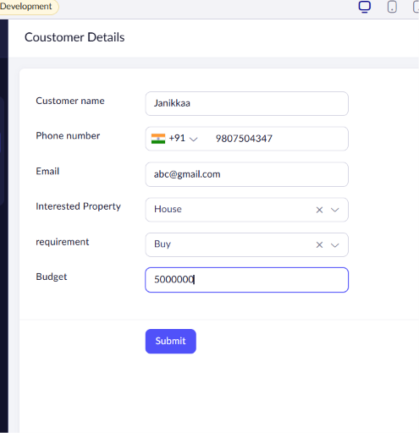
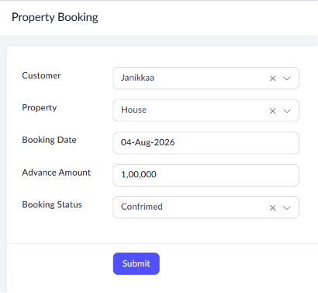
Result
The Property Buying & Rental System was successfully developed using Zoho Creator. The application allows users to add and manage property details, customer information, and property bookings using lookup relationships. The system stores and retrieves data through the cloud, thereby successfully demonstrating the Software as a Service (SaaS) model.

